**TEAM EXCEPTIONS - DESIGN DOCUMENT**:

This document contains the ER diagram, Data flow diagram, UML diagram and table structures

1. Data Flow Diagram:  
   This diagram shows the entire flow of the project, and how entities work with each other, functionalities involved, which can give a thorough idea of how bug tracking system works.

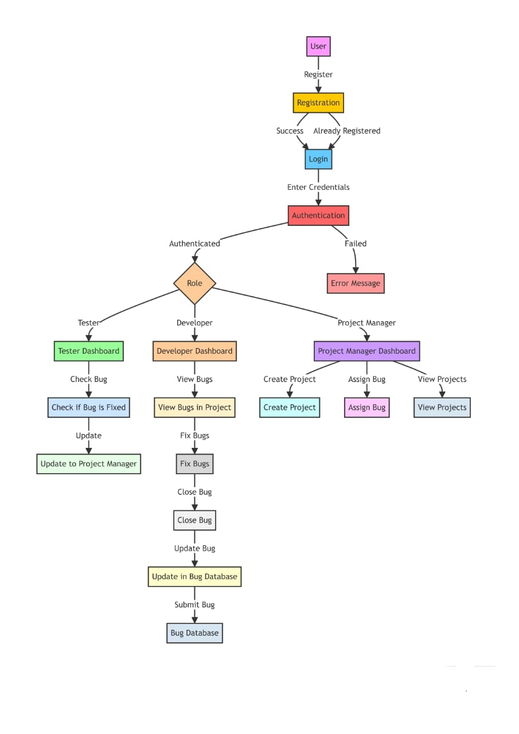

1. ER diagram: This gives an overview of the tables used at the backend section of our project. It highlights the various primary keys, foreign keys, relationships and dependencies.

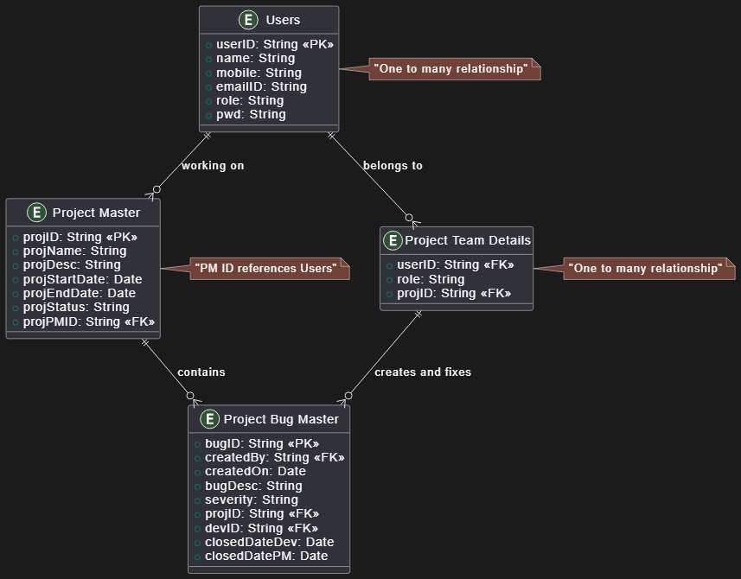

1. UML diagram:

This diagram highlights the various entities of the application and their corresponding states and behaviour. It includes – Projects, Project managers, testers, developers, bugs. Behaviour of every entity is defined as a method. Plus the arrows show the interdependencies between

these entities.

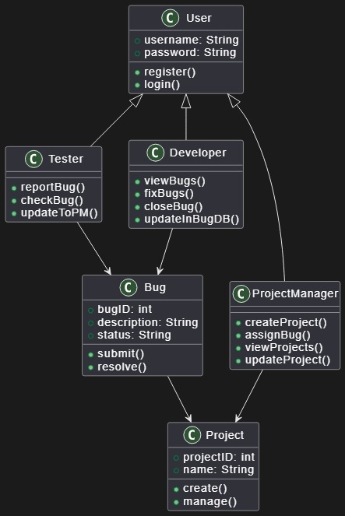

We also have the table structures as described using “desc” command in the MySQL database.

